FASSET - A dynamic whole-farm simulation model

Preface

1. Introduction

FASSET is a farm-scale model that simulates many of the characteristics important to society today; production, economics and pollution.

The sources of pollution described include nitrate leaching, ammonia emission and the emission/absorption of greenhouse gasses. Other sources of pollution are only peripherally described e.g. phosphate is described in terms of field/farm balances and pesticides are only considered in terms of the amount used. FASSET is a dynamic, deterministic model i.e. it can simulate changes over time but will always give the same outputs when presented with the same inputs. The model uses a daily time step for most simulations.

Version 1 of FASSET described only pig and arable farms but included a linkage to an economic optimisation model that simulated crop rotations and fertiliser/manure use. The latter was programmed in GAMS whilst FASSET was programmed in C++. This construction proved difficult to implement and maintain so has been omitted from Version 2 in favour of the progressive inclusion of decision-making within FASSET itself. FASSET v 2 has been extended to describe dairy and beef cattle.

2. System overview

FASSET is constructed in modular form. The use of object oriented programming techniques means that the model can be readily adapted to a wide range of farms with, for example, different numbers of fields or animal housing types.

2.1 System components

The main groupings of modules are those describing livestock, fields, equipment and structures, and management (Fig 1).

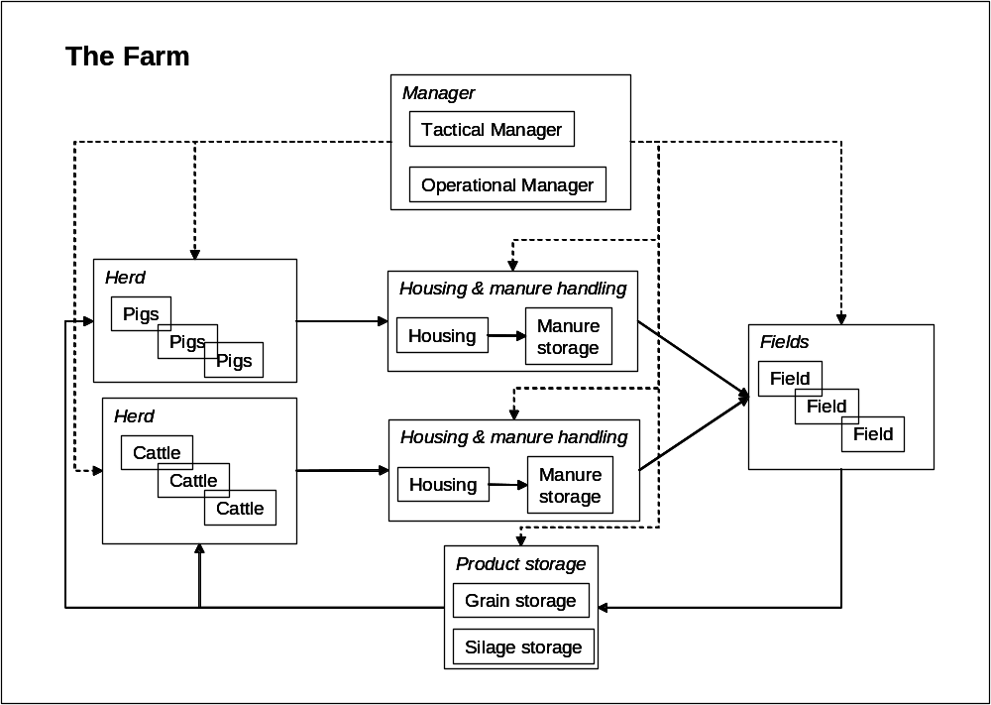
Fig 1 Main components of the FASSET model. Solid lines show the flow of material was dashed lines show the flow of information.

2.2 Simulation of flows within and between components

The following flows are simulated within the model; nitrogen, carbon, phosphate and water. (What else do we need here?)

3. Livestock

The model can currently described pigs and cattle. All animals must be associated with a location in an animal house. This is to enable the model to correctly route the manure produced. For further details, see Animal housing.

3.1 Pigs

The model currently only considers pigs that are housed year-round. The pig production is modelled as a steady state process. The production statistics (e.g. growth per day, length of production cycle, pig diets) are input to the pig module on an annual basis. The module then calculates the average daily import of nutrients in feed and the export in weight gain, dung and urine.

The pig herd consists of mating sows, pregnant sows, lactating sows (including suckling piglets up to weaning), weaners, finishers and replacement sows. Production sows are further subdivided into mating, pregnancy and lactating animals. The boars are not represented.

Each type of pig can receive different feed mixtures and can be housed in different sections of the animal house. The model performs a nutrient balance for the animals, enabling the nutrients consumed in the diet to be partitioned between animal growth and manure excreted (and for C, CO₂ exhaled). This means that the manure they produce can be separately routed to the appropriate animal section and manure storage (Fig 2).

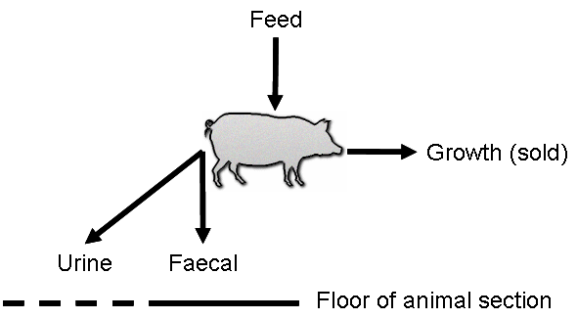
Fig 2 Schematic representation of mass flow in a housed animal

The urine and faeces excreted are characterised in terms of their content of C, N, dry matter, diverse elements (e.g. P, K, Ca) and water. The subsequent transformations in the manure are simulated in models of animal housing, manure storage and the fields.

3.1 Poultry

Not currently described in the model.

3.3 Cattle

Unlike the pigs, the cattle herd is considered to consist of one or more individual cows or cow types (i.e. typical animals that represent more than one individual) and production statistics are simulated by the module. This is because the management of cattle varies to a much greater extent than for pigs. For example, the cattle diets are more variable (roughage, concentrates) and the cattle may be housed or at pasture, depending upon the production system and time of year. The herd structure is defined in terms of a number of animal groups, based on the age, sex and production objectives (beef or dairy) of the animals.

The production and excretion of cattle is simulated as a function of the energy and protein supply in the diet. The amount of feed consumed and its chemical composition is dependent on the quantity and quality of feed available to the animals and the constraints on the ability of the animals to consume the feed on offer. There are two constraints on feed consumption. The first is a quality constraint and is related to the rate at which the feed can be decomposed in the rumen while the second is a quantity constrained, related to the amount of feed available. It is assumed that the feeds on offer are consumed in order of increasing fibre content. If sufficient feed is available, the feeds are consumed until the animal’s capacity for consuming fibre is reached. If this occurs, some of the feed on offer will not be consumed. If this is not the case, all the feed will be consumed and the proportion of the animal’s feed intake capacity will not be utilised. For housed animals, the amounts of the different feeds on offer equates to the feed ration. Where some or all of the feed is consumed by grazing, the amount of feed on offer is made a function of the herbage mass density (kg DM ha⁻¹).

As for the pigs, each type of cattle can receive different feed mixtures and can be housed in different sections of the animal house. The model performs a nutrient balance for the animals, enabling the nutrients consumed in the diet to be partitioned between animal growth and manure excreted (and for C, CO₂ and CH₄ emitted). This means that the manure they produce can be separately routed to the appropriate animal section and manure storage.

3.3.1 Dairy

Although the cattle are modelled as individuals or representative individuals, they are input and nearly into the model in a number of categories: heifers 0-0.5 years, heifers 0.5-1.0 year, heifers 1.0 year - first calving and mature dairy cows. The individual animals grow from calves to mature cows. The model maintains the same number of animals in each category throughout the year. When and animal reaches the upper age limit of its category, it is promoted to the next category if there is space, or it is sold. It is replaced by an animal of age equivalent to the lower age limit of the category by recruitment from the preceding each category (or, for the youngest category, as a newborn calf). If no animal is available, one is bought.

3.3.2 Beef

The beef cattle are modelled in the same way as the dairy cattle, although using different age categories. The age categories for beef cattle are: mature suckler cows, female calves 0-0.5 years, female calves 0.5-1.0 year, female calves 1.0 year - slaughter, male calves 0-0.5 years, male calves 0.5-1.0 year and male calves 1.0 year - slaughter.

3.3.3 Cattle feeding

Mature dairy and suckler cows are managed in groups:
- First lactation, early lactation
- First lactation, late lactation
- Second or more lactation, early lactation
- Second or more lactation, late lactation
All other age categories of cattle are managed as homogenous units.

The cattle feeding can be specified in two ways. In the first, the diet is defined in an input file in terms of specific amounts of specific feeds. The feed items on offer in the diet are assumed to be selected for consumption in order of decreasing digestibility, until intake reaches the animal's capacity or until there are no further feed items on offer. In the second method, the diet is specified in terms of one type of roughage feed and one type of concentrate, plus the proportion of energy that is intended to be supplied by the roughage feed. If the cattle are grazed, the proportion of roughage feed to be obtained by grazing is also input. Based on the animal's demand for energy and protein, the absolute amounts of the roughage feed and concentrate are then calculated.

If the cattle are grazed, the grazed feed ration obtained by the first or second method described above is treated as the intended ration rather than the actual ration. The actual ration is calculated during simulation and is dependent on the availability of grazable herbage.

3.4 Sheep (?)

4. Buildings and storage

The buildings and storage represented in the model either house livestock or store some commodity. Often, the commodity being stored is the crop product such as grain awaiting sale or silage that is to be fed to livestock over the winter. In these cases, the storage is passive i.e. has no other function in the model than keeping a record of the quantity and quality of the items stored. However, in the case of manure in animal housing and manure storage, the model simulates the biological transformations (e.g. decomposition of organic matter) and emission of C and N gases.

4.1 Animal housing

An animal house is considered to contain one or more animal sections, where an animal section is defined as an area of the housing to which an identifiable group of animals is confined (see Fig 3). This will most commonly be identified with a pen or stall. For example, a pig house could contain separate sections containing dry sows, sows with suckling piglets and weaned piglets. The user defines the number of sections and within constraints of PC memory and speed, there can be an unlimited number of animal sections within a single animal house.

Each animal section consists of either one or two floor areas and each floor area can contain one or two manure types. For example, an animal section could contain an area that is slatted and an area that is solid. A floor area could contain a single manure (slurry or farmyard manure) or two manures (dung and urine separately). The animal house can contain a storage facility can either be within the animal house (slurry pit or slurry channel) or external (slurry tank or manure stack). In the case of solid manure that is stored on the floor of the animal section until field application, no receiving storage facility is defined. In all cases, the model routes the passage of the manure through the manure management system, so that mass conservation is maintained.

The emission of ammonia and evaporation of water from the floor of the animal housing is simulated dynamically and is a function of the chemical characteristics of the manure, the temperature in the animal housing and the ventilation rate. The animal house has either forced ventilation (powered by fans) or free ventilation (wind-driven). In both cases, it is assumed that farmers attempts to maintain inside temperature within a tolerable range by adjusting the ventilation via the fans (forced ventilation) or via an adjustment of the size of the openings in the side of the housing (free ventilation).

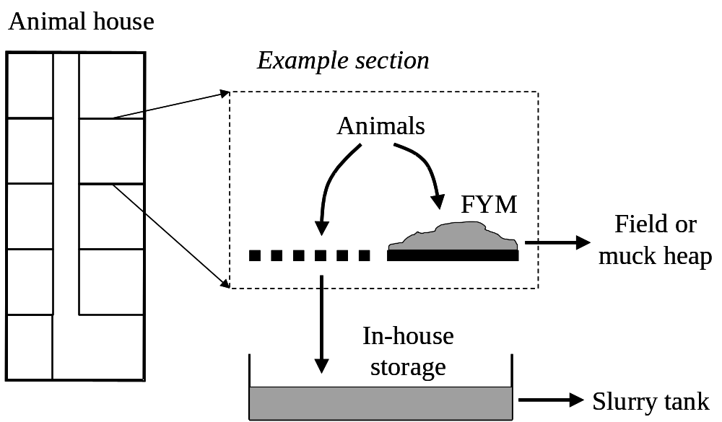

Fig 3 Schematic representation of animal housing and manure storage model

4.2 Manure storage

Manure can be stored in the form of a solid or liquid and can be stored inside or outside the animal housing. In both cases, the model simulates the transformations of C and N during storage and losses of C, N and water to the atmosphere. The losses of C can occur as CO₂ and CH₄ whereas the losses of N can occur as NH₃, N₂O or N₂. The manure in storage can either be removed for application to the field or exported.

5. Machinery

6. Fields

A field is an area of land that is managed as a unit. A field can be divided into two new fields e.g. if a field that has previously grown a single crop is subsequently divided into two smaller fields, each growing separate crops. Note that at present, there is no facility for the remerging fields once they have been divided.

6.1 Patches

A field contains one or more patches, allowing in theory heterogeneity in soil characteristics to be represented. In a previous version of the model, this facility was used to investigate the consequences of the uneven distribution of excretal returns from grazing animals. This capacity has yet to be re-implemented in the current version. The facility could also in the future simulate the effect of variations in soil type within a field.
6.2 Field operations

The following field operations can be performed; tillage, fertilisation (with mineral fertiliser or animal manure), sowing, irrigation, spraying herbicide and harvesting. For a number of these operations, it is possible to specify certain aspects of the operations. For example, for the fertilisation with animal manure it is possible to specify the application technique, whilst for harvesting operations, it is possible to specify whether the secondary crop product (e.g. straw) is removed from the field or left on the soil surface.

7. Patch/Ecosystem

There is a one-to-one relationship between a patch and an ecosystem; the two are separately identified simply because in the longer term, it will be possible to run the ecosystem model independently of FASSET. Most of the functionality lies in the ecosystem model. The functionality in the patch model only considers the following:
- The age of a patch and whether it is grazable. This information is only used when simulating the heterogeneity that results from the uneven distribution of excretal returns. This is not currently enabled.
- The generation of a feed item from the information held in the ecosystem model. Feed items are used to communicate to grazing animals that feed that is on offer to them. The information contained in the feed items enables the grazing animals to select how much to graze from the patches accessible to them.
- The emission of ammonia from the field applied fertiliser and manure is simulated by the patch model.

The ecosystem model contains as a minimum a soil model. In addition, the ecosystem model can contain up to 4 crop models simultaneously. This enables the model to simulate mixed cropping e.g. barley/pea with undersown grass/clover. The ecosystem model simulates the competition between the crops……

Need details here about the interactions between crops between the crops and the soil.

7.1 Soil

The soil model handles the following processes:
- Water transport, and evaporation and transpiration by soil and plants.
- Nitrogen transport, turn over, loss and uptake by plants.
- Soil temperature.

The model is run in daily time steps. The driving variable that are supplied to the soil model by the fields object prior to each daily update are: mean air temperature, precipitation and irrigation, potential evaporation from soil surface and a number of plant specific parameter. These plant parameters includes potential evapotranspiration from green and dead leaves, root radius, root length, water pressure potential at root surface, nitrogen demand and maximum nitrate and ammonium uptake rates.

The soil model has a one-dimensional vertical structure consisting of an interception layer, a soil surface and a soil profile. The interception layer handles water interception and evaporation from the surface of the plant canopy. The soil surface handles snow accumulation, soil evaporation and has pools of organic and mineral nitrogen that may later be made available to the soil profile.

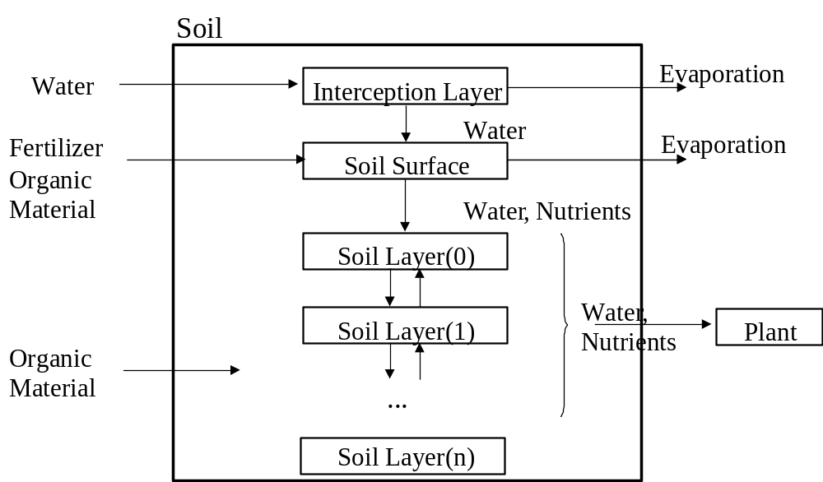

Interception layer
Handles the interception of water by the crop canopy. The evaporation of snow and water from this layer is calculated from estimation of the potential evaporation.

Soil surface

The soil surface handles evaporation from soil and application of fertilizers and manure to the soil.

Soil profile
The soil profile consist of a number of vertical soil layers of variable thickness (se below). Each layer is described by a number of fixed physical and chemical properties as layer thickness, density, holdback constant, drainage constant, field capacity, clay content and pF curves. Within each layers these properties are assumed to be constant. The dynamic variables in each layers are nitrate content, ammonium content, temperature and water content.

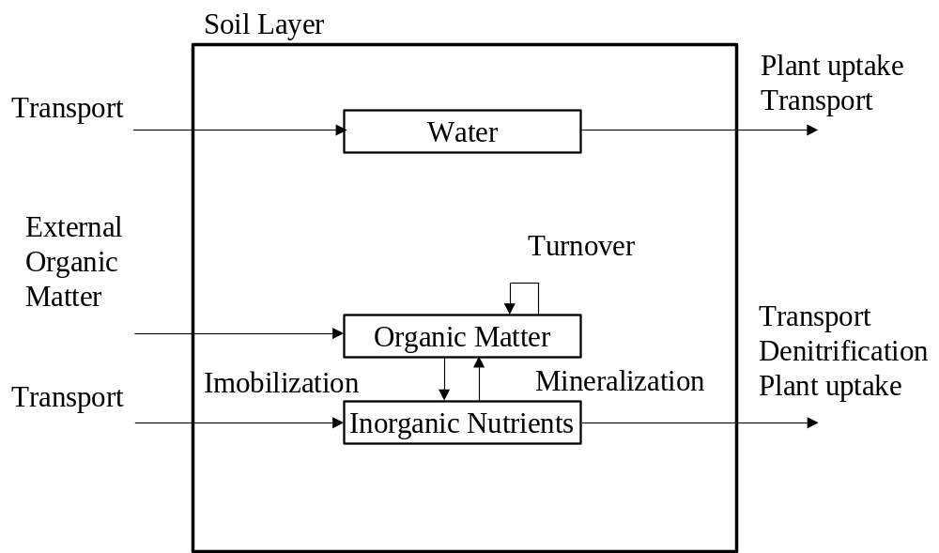

Temperature
The temperature in each layer are calculated according to the principles outlined in the SOIL model (Jansson 1996). The numerical solution of the differential equation describing the problem is done with a Newton method with varying time steps.

The paragraph above is not very descriptive. Needs to be rewritten.

Links to level 2.

Organic pools
Each layer has a number of organic pool. These pools are divided into a number of different pools according to origin and resistance to biological turnover rates as describes by Hansen et al. (1991). Each pool are characterized by its carbon and nitrogen content and a first order turnover constant. Turnover rates are modified depending on the soil layers clay content, temperature and water content.

Nitrification and denitrification
The oxidation of ammonium (nitrification) is described by first order kinetics. The rate constant is corrected for effect of soil water and temperature. The denitrification is described in a similar manner.

Uptake of nitrogen and water by plants
A simplified version of the principles in the DAISY simulation model (Hansen et al ,1990) is used for simulation of the water uptake. In addition uptake from different species are allow using principles from resource allocation in food webs (Screiber and Gutierrez, in press). The uptake of nitrogen is as described by Hansen et al (1990) modified amongst others to account for several plant species.

Transport of water and nitrogen in the soil profile
The transport of water and nitrogen is calculated using the concepts of the Solute Leaching Intermediate Model (Addiscott and Whitmore, 1991) combined with a simple model of water movements due to gradient in water potentials. Water potential are calculated from retension curves.

7.1.1 Soil temperature

Link to level 2.

7.1.2 Soil water

7.1.3 Soil carbon and nitrogen

7.2 Plants

The major processes considered in the crop sub-model are crop development, leaf area expansion, assimilation of carbohydrates and nitrogen and dry matter partitioning and transfer (Petersen et al., 1998). The phenological development is simulated by discrete growth phases governed by thermal age. For robustness, the assimilating green crop area is not partitioned into single leaves. The model acts as a variant of a “big leaf model”. The crop sub-model simulates daily net dry matter production from light interception using a radiation efficiency index that depends on temperature, crop nitrogen status and water availability. The biomass is partitioned into effective biomass of roots, vegetative top and storage organs respectively.

Light interception is calculated from leaf area, which in turn is simulated using expansion rates depending on crop phenological state, dry matter, temperature, nitrogen content and soil water status.

For nitrogen fixating crops, the N-fixation is assumed to depend on daily dry matter production and nitrogen deficiency, such that the fixation decreases with increasing availability of nitrogen in the soil.

The minimum and maximum amount of nitrogen in the crop is a function of leaf area and dry matter in the various parts of the crop. The radiation use efficiency is zero when the nitrogen content equals the minimum amount, and radiation use efficiency reaches maximum if the nitrogen content is at maximum level. The nitrogen demand is the difference between maximum and actual nitrogen content. Availability of water is another stress factor, implying that crop production decreases with increasing water deficiency. Nitrogen uptake and actual transpiration is calculated by the soil sub-model. The major processes in the crop sub-model are illustrated in figure 4.3.

The uptake of water and nitrogen can be either limited by crop demand, availability in the root zone or the ability by the roots to absorb them. The spatial distribution of the root system is simulated by the principles outlined in Gerwitz & Page (1974).

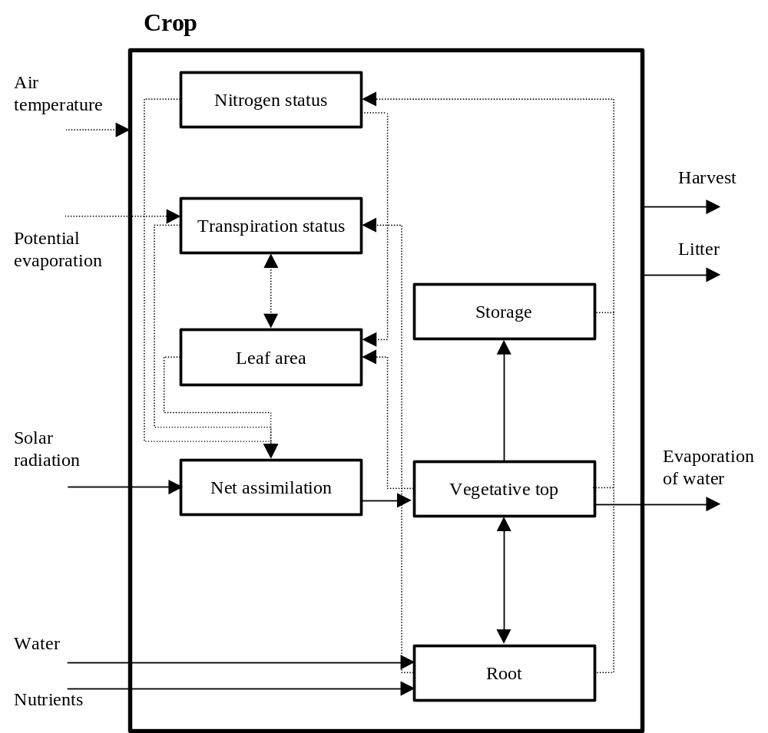
In case of severe frost crops like winter-barley and wheat can actual die and a different crop (spring barley or peas) than have to be sown in the spring. The model can presently not deal with this situation.

Figure ??. The crop sub-model

7.2.1 Crop development

7.2.2 Crop growth

Root growth and N uptake

Link to level 2

7.2.3 Carbon and nitrogen turnover

Link to level 2.

8. Farm management

Model is typically used in two ways; to simulate historical situations, where the management is known, or to simulate scenarios, where it is not. The simulation of historical situations is most often restricted to one component of the model e.g. the field model or the cow model. There are two reasons for this. The first is that it is rare to have detailed data available for the whole farm. The second is that model error, combined with the interaction between components, constrains behaviour. For example, when simulating the manure management system and fields in combination, field records could show that manure was transferred from manure storage to the field at a time when model error meant that the simulated manure storage was empty.

Since the FASSET model originally consisted of an economically-based management model and an earlier version of this biophysical model, little management is simulated dynamically here. For example, there is no crop rotation model present and relatively little simulation of tactical field management (the exception of grassland). There is no dynamic simulation of pig management but limited dynamic simulation of cattle feeding.

8.1 Cattle feeding management

For most categories of cattle, the diets are inputs to the model. However, for lactating dairy cows that are grazed for part of the day, there is a facility to adjust the ration of barn-fed feed to compensate for fluctuations in the availability of grazable herbage.

8.2 Grassland management

When simulating grassland management, it is assumed that farmers will attempt to conserve sufficient roughage feed during the growing season to supply the demand for roughage feed during the winter. The demand for conservatory is calculated from the type and number of cattle present and the cattle feed plan that is input. The growing season is then divided into a number of growth periods. At the start of each growth period, the demand for grazed herbage is calculated and the expected herbage growth rate is estimated. The number of fields to be grazed is then calculated such that the expected production of grazable herbage matches the expected demand. The remaining fields of roughage crops are then allocated for the production of winter feed. This process is repeated for each growth period, until the winter feed requirement has been satisfied or until the end of the growing season.

When allocating fields for grazing or winter feed production, fields closest to the farm buildings are used for grazing dairy cattle whilst those furthest from the farm buildings are used for grazing livestock that do not need to return to the animal housing during the day (e.g. heifers).

8.3 Manure management

The amount of manure handled by the manure management system (i.e. animal housing and manure storage) depends on the number and type of livestock on the farm and the extent to which they are grazed. The amount of manure applied to the fields is determined by the area of the fields and the crop management plans, both of which are inputs to the model. Since the manure production cannot be calculated precisely a priori, there is often a systematic imbalance between the demand and production of manure. Over time, this lead either to under-fertilisation or persistent importing of manure (if demand exceeds production) or the accumulation of manure in the storage (if production exceeds demand). The model therefore has a facility that allows the application of manure for the fields to be increased or decreased over time, to balance demand to supply.

9. System indicators

The model outputs a range of production, economic and environmental statistics on an annual basis. This includes complete farm-scale budgets for C, N and water, with separate accounting for cattle, pigs, animal housing, manure storage, crops and soil. In addition, more detailed daily output can be requested from the cattle, animal housing, manure storage, fields, crop and soil submodels.

Do we need references in level 1 documentation?
References

Addiscott, T.M. & Whitmore, A.P. (1991). Simulation of solute leaching in soils of different permeabilities. Soil Use and Management 7, 94-102

Hansen, S., Jensen, H.,E., Nilsen, N.E. & Svendsen, H. (1990). DAISY – Soil plant atmosphere system model. Npo- forskning fra Miljøstyrelsen. Nr. A10. Miljøstyrelsen, Copenhagen. 272 pp.

Hansen, S., Jensen, H.,E., Nilsen, N.E. & Svendsen, H. (1991). Simulation of nitrogen dynamics and biomass production in winter wheat using the Danism simulation model DAISY. Fertilizer Research 27, 245-259.

Screiber, R.S. & Gutierrez, A.P.- (in press). A supply/demand perspective of persistence in food webs: applications to biological control. Ecology.

Jansson, P-E. (1996) Simulation Model for Soil Water and Heat Conditions. Swedish university of agricultural sciences.

Justes, E., Mary, B., Maynard, J.-M., Machet, J.-M. and Thelier-Huche, L. 1994. Annals of Botany 74:397-407.

